Call for Chinese women to take action against a longstanding national emergency
呼吁中国妇女采取行动应对长期的国家紧急状况
In China in 2008, six babies died and 300,000 got sick from milk that was knowingly and intentionally contaminated with the poison melamine. There was a national and international outcry of anger and disgust against this atrocity; such things should not be allowed to happen. Action was swift and definitive: several of those responsible received the death penalty for their part; many others, including 66 year-old Sanlu ex-boss Tian Wenhua, received life sentences or other punishments.
2008年，中国爆发三聚氰胺毒奶粉事件，其导致6名婴儿死亡，30万婴儿患病。引起世界范围内民众的极大愤怒和谴责。此类事件不应该允许发生。事件爆发后，执法机构采取了迅速明确的行动，若干责任人因此被判处死刑,66岁的三鹿前老板田文华被判处无期徒刑,对相关涉案人员采取了对应惩处措施。
That very same year, and every year since and even many before, another atrocity has an occurrence in China that needlessly takes the lives of more than 20,000 infants and children—not six—20,000. But where is the outcry? Where is the action?
就在同一年，此后甚至更早以前的每一年，此类事件仍在发生，不必要地夺走2万多名婴儿和儿童的生命，数字从6变成了2万。但我们的抗议在哪里?行动又在哪里?

President Xi has reemphasized many times what we already know, that family is foremost in China. Articles 48 and 49 of the Chinese Constitution call for complete equality for women in every aspect as well as for freedom from violence for all people including children, whose guaranteed safety is specifically mentioned in Article 49.

习主席多次强调家庭的重要性，中国宪法第48条和第49条要求妇女在各方面享有完全平等的权利，并要求包括儿童在内的所有人免于暴力，第49条特别提到保障儿童安全。
His wife, Peng Liyuan, has expanded upon her husband’s stance on the importance of women taking on active roles in furthering the cause of building the “moderately prosperous society of socialism with Chinese characteristics.” She is an inspiration not only to women, but to all people, including myself.
妻子彭丽媛,以此为根基，更近一步推进了女性在建设中国特色社会主义与全面建设小康社会的进程并发挥着积极的作用。“她不仅激励着女性，也激励着所有人，包括我自己”。
We have been dealing successfully with COVID-19; while the U.S. COVID-19 death toll approaches 250,000, China’s powerful response has kept its death count to just 4,634. Hopefully, this is a once in a lifetime pandemic, and extreme measures will not again be necessary nationwide. But there is an ongoing health emergency taking hundreds of thousands of lives every year, and it too is preventable.
我们已经成功地应对了新冠肺炎，而美国新冠肺炎死亡人数接近25万，但中国强有力的应对措施使死亡人数仅为4,634人。但愿新冠只此一次，不再卷土重来，全国人民不再需要采取任何极端措施进行防护。但是，每年都有一场夺走数十万人生命的持续的卫生紧急情况事件发生，所幸这也是可以预防的。
Toward the end of the Chinese Civil War, a new tradition that grew out of the war became firmly entrenched in Chinese culture. By 1947, “guanxi,” an obligation of one party to another that is built over time by the reciprocation of social exchanges and favors, became heavily dependent on the cigarette. For the Nationalists, Kai Shek liked Big Double Nine; for the Communists, Mao liked 555, Zhou Enlai liked cigarettes from the Zhadan company; and Deng liked Panda (700元 per pack).When two Chinese soldiers on the same side would meet, they would exchange cigarettes as a sign of friendship, a symbol of guanxi. When villages were captured or freed, cigarettes were exchanged among the men, but not the women. At that time, people did not know of any health issues with cigarettes; some doctors even prescribed cigarettes to treat certain symptoms and diseases! After the War, the guanxi cigarette tradition continued to this day, and the exchange of cigarettes is considered by many to be an important component of business negotiations as well as a sign of friendship.
内战结束时，一种新的传统在中国文化中根深蒂固。到1947年，“搞关系”—-这是一种随着时间的推移而建立起来的用于社交利益互换的一种社会现象，其纽带严重依赖于香烟。对于国民党而言，蒋介石喜欢抽大重九，对共产党人而言，毛喜欢抽555，周恩来热衷于志丹卷烟厂的香烟，而邓则亲睐于熊猫牌香烟(700元/包)。当同党派的两名中国士兵见面时，双方用互换香烟的方式来作为维持友谊和关系的象征。当村庄被占领或解放时，男人之间会交换香烟，而女人则不会。当时，人们并不知道吸烟会带来任何健康问题，有些医生甚至用香烟来治疗某些症状和疾病!战后，“关系烟”的传统延续至今，许多人认为交换香烟是商业谈判的重要组成部分，也是友谊的象征。

Three years after cigarettes were embedded as a part of Chinese culture, something new happened. In 1950, the first scientific proof of causation of smoking and lung cancer instead of just correlation was published. Suddenly there was a need to stop people from smoking to protect their health, but it was already too late—the addictive nature of the nicotine found in the tobacco ensured that men would continue smoking. But far more important, the Chinese men were not about to give up an essential part of their doing business; cigarettes as a tool for expressing guanxi was here to stay.
在香烟成为中国文化一部分的三年后，一些新的事情发生了。1950年，首次有科学研究证明了吸烟和肺癌的因果关系，而不仅仅是两者之间的相关性。阻止人们吸烟以保护人们的健康成了当务之急，但为时太晚——烟草中发现的成份尼古丁让烟民们逐渐抽烟成瘾，但更重要的是，中国人不可能会放弃为生意获取利益的香烟，作为利益纽带，香烟成为一种表达关系的工具在这里延留了下来。
Meanwhile, cigarette sales flourished, and were massive enough that even a modest tax on the sales was sufficient to provide more than 7.5% of the national government’s income. Additional ongoing research proved the connections between smoking and many other health issues including forms of cancer other than just lung cancer.

与此同时，卷烟销售繁荣，规模之大，对卷烟销售征收的适度税收足以为国家政府提供7.5%以上的收入。其他正在进行的研究证实了吸烟和许多其他健康问题之间的联系，包括除了肺癌以外的各种癌症的产生也与此息息相关。
In 1964 the Surgeon General, the highest medical authority in the U.S., issued an official statement that connected smoking with diseases and a shortened lifespan. As was the case for the milk industry in the 2008 milk scandal in China, the tobacco industry hid most of their own research that showed just how dangerous smoke was to the smoker, but also hid the information that showed a connection between non-smokers getting the same illnesses that the smokers were getting.
1964年，美国最高医疗权威卫生局局长发表了一份官方声明，这份声明将吸烟与疾病和寿命缩短之间存在的关系关联起来。就像奶制品行业在2008年曝出的奶粉丑闻事件，烟草行业也隐藏着内部已知吸烟有损健康的相关研究信息，还同时隐藏了吸二手烟的人群同样会患上疾病的相关信息。
In 2005, the World Health Organization reported that any benefits of China’s fiscal gain from the cigarette tax was now cancelled out by China’s monetary losses due to illnesses and deaths related to smoking. That was the impetus for Beijing to begin its anti-smoking policies.
2005年，世界卫生组织(World Health Organization)报告称，中国从烟草税收中获得的任何财政收益，现在都被吸烟所导致的疾病和死亡造成的经济损失而抵消了。这就是中国政府开始禁烟政策的动力。

“There is no safe level of exposure to second-hand smoke.”… “Ventilation equipment is ineffective in reducing the harm from exposure to second-hand smoke.” These quotes are from the “2007 China Tobacco Control Report” of the Chinese Ministry of Health. Stated another way: if you can smell cigarette smoke, your health is being compromised; if someone is smoking anywhere in a building, the health of everyone in that building is being compromised.
“接触二手烟没有安全标准。通风设备在减少接触二手烟的危害方面是无效的。以上引文摘自中国卫生部《2007年中国烟草控制报告》。换句话说:如果你能闻到烟味，你的健康就受到了损害，如果有人在大楼的任何地方吸烟，大楼里每个人的健康都会受到损害。
For the first time China was ahead of the U.S. in its stance against smoking: it took the U.S. Surgeon General another four years before he made the same official statement in 2011.
In today’s China, more than 350 million people are smokers. More than half of the men are smokers; less than 6% of women are smokers. More than 600 million are exposed to second- and third-hand smoke (defined below), including 180 million children.

中国反对吸烟的立场第一次超过了美国，美国卫生部长在过了四年之后才在2011年发表了同样的官方声明。
在今天的中国，有超过3.5亿人吸烟。超过一半为男性，女性的吸烟比例不到6%。超过6亿人暴露于二手烟和三手烟中(定义如下)，其中包括1.8亿儿童。

What is today’s national health emergency? Simply stated: Every year in China, more than one million people die from smoke-related illness. Of the million smoke-related deaths, more than 100,000, or ten percent are infants, children, and women who are exposed to second-hand smoke. Estimates place the number of infant and child deaths at around 28,000 per year. Every year.
今天的国家卫生紧急事件是什么?简单地说，在中国，每年有一百多万人死于与吸烟有关的疾病。在与吸烟有关的100万例死亡中，暴露于二手烟的婴儿、儿童和妇女超过10万人，占10%。据估计，每年婴儿和儿童死亡人数约为28 000人。

Another complicating factor is the danger of what is called “third-hand smoke,” which is the smoke that sticks to clothes, hair, skin, furniture, and the insides of cars, buses and trains. Studies show that exposure to third-hand smoke carries the same risk as second-hand smoke. Remember, the smoke from just one cigarette may be enough to kill. When the father comes home from work and he has the smell of cigarette smoke on his clothes and he picks up his infant baby for a hug, that baby is breathing in the third-hand smoke next to its nose, and could die that very night. When the mother who works in a smoke-filled environment comes home from work and she has the smell of cigarette smoke on her clothes and she picks up her infant baby for a hug, that baby is breathing in the third-hand smoke next to its nose, and could die that very night. The parent or the adult may have just committed murder.
另一个复杂的因素是所谓的“三手烟”带来的危险，三手烟会粘在衣服、头发、皮肤、家具上，以及汽车、公共汽车和火车的内部。研究表明，接触三手烟带来的风险与二手烟相同。记住，一根烟的烟雾就足以致人于死地。父亲下班回家，衣服上有烟味，抱起自己的婴儿，婴儿鼻子旁边吸着三手烟，当晚可能就能致命。当母亲在烟雾弥漫的环境中工作下班回家香烟的味道吸附在她的衣物上,当她抱起并亲吻婴儿，婴儿直接吸入三手烟，极有可能当晚致命。父母或成年人这一不经意间的举动，可能就犯上了谋杀罪。
Yes, it is that serious.

28,000 Chinese infants and children die each year from exposure to second-hand and third-hand smoke.

是的，有那么严重。

中国每年有2.8万婴幼儿死于二手烟和三手烟。
It is time for women to take action; here is what you are being called to do:
现在是妇女采取行动的时候了，以下是你呼吁要做的事:

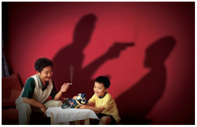
Step One: protect the children! Do not allow them to be exposed to cigarette smoke. Every adult has a responsibility to take care of all children. Because of the danger of smoke from even one cigarette, do not hesitate to immediately stop someone from smoking around a child. If you saw someone holding a gun or a knife to a child’s head, you would not hesitate to stop them. You would not take the time to explain why the person should not hold the gun to the child’s head! For some children, cigarette smoke could be just as deadly. If a child is being exposed to cigarette smoke, the danger is immediate, and you should not take the time to explain the danger; you should first save the child and explain later. Today in some countries and some states and provinces in the U.S. and Canada, it is a crime to expose children to smoke and the punishment can include jail time and even separation from the children. Smoking in a moving car that has the windows down still has as much pollution as Beijing on its worst pollution days; smoking in an elevator or even when just walking down a hallway may leave second-hand smoke in the air for as long as 30 minutes. Smoke in a bathroom can linger for as much as an hour or more.
第一步:保护孩子!不要让他们暴露在香烟烟雾中。每个成年人都有责任照顾所有的孩子。由于吸烟的危害，即使是一根烟，不要犹豫，立即阻止某人在孩子周围吸烟。如果你看到有人拿着枪或刀对着一个孩子的头，你会毫不犹豫地阻止他们。你不会花时间去解释为什么那个人不应该拿枪对着孩子的头!对一些孩子来说，吸烟也是致命的。如果孩子暴露在香烟烟雾中，危险是即时的，你不应该花时间解释这种危险，你应该先救孩子，然后再解释。今天，在美国和加拿大相关州和省都采取了措施，让孩子暴露在有烟环境中已经是一种犯罪，惩罚可能包括坐牢，甚至与孩子分开。在一辆开着窗户的移动汽车里吸烟所造成的污染仍然和北京污染最严重的日子一样多，在电梯或走廊吸烟可能会在空气中留下长达30分钟的二手烟。在浴室里吸烟会持续一个小时甚至更长时间。
Please note: this is not a call for making people quit smoking; less than 2 out of 5 can safely and successfully quit. Those who started smoking before the age of 15 simply cannot quit; their young brain chemistry has been permanently altered in such a way that they have to have nicotine in order to function “normally.”
请注意:这不是号召人们戒烟，不到五分之二的人可以安全地成功戒烟。那些在15岁之前就开始吸烟的人根本无法戒烟，他们年轻时的大脑化学物质被永久地改变了，因此他们必须摄入尼古丁才能“正常”工作。
It is a call to protect non-smokers from exposure to second- and third-hand smoke.
它呼吁保护非吸烟者免受二手烟和三手烟的危害。
Step Two: Join with other women! You (both women and men!) can join the All-China Women’s Federation and share in their work to educate China about the dangers of second- and third-hand smoke.
第二步:加入其他女性!你们(男女都可以!)可以加入全国妇女联合会，参与他们的工作，向中国宣传二手烟和三手烟的危害。
Step Three: Educate! Educate yourself, your children, your other loved ones and friends. If you’re in an apartment or gated community, express your concerns to the management, and have them post “no smoking” notices. Most provinces have special sections regarding tobacco control—how to quit, how to minimize the damage if you can’t quit (only around 2 out of 5 are able to completely quit), and what your rights are as a non-smoker to ensure enforcement of local, provincial and national smoking regulations. They will also have resources to help in understanding the severe danger cigarette smoke poses to both smokers and non-smokers.
第三步:教育!教育你自己，你的孩子，你其他的爱人和朋友。如果你住在公寓或封闭式社区，向管理层表达你的担忧，并让他们张贴“禁止吸烟”的告示。大多数省份都有关于烟草控制的专门章节——如何戒烟，在无法完全戒除的情况下该如何将危害降到最低(只有大约五分之二的人能够完全戒烟)，以及作为非吸烟者，你有什么权利确保执行地方、省和国家的吸烟规定。他们也有资源帮助人们了解吸烟对吸烟者和非吸烟者产生的巨大的危险。

Step Four: Put up signs and posters! You can help public places enforce no smoking policies by providing posters you create yourself or you get from your local or provincial Tobacco Control office. You can also put up posters in your own home.
第四步:张贴标语和海报!你可以通过提供自己制作的海报或从当地或省级烟草控制办公室获得的海报来帮助公共场所执行禁烟政策。你也可以在自己家里贴海报。
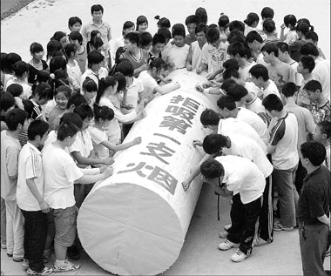
Step Five: Attend events! Occasional non-smoking related events occur year round; the best known international event is the World No Tobacco Day every May 31. Many schools, health facilities, and local governments often have special events to celebrate that day.
第五步:参加活动!全年偶尔会有与禁烟有关的活动，最著名的国际活动是每年5月31日的世界无烟日。许多学校、卫生机构和地方政府经常在这一天举行特殊活动进行宣传。
Step Six: talk with your local and Party representatives! China’s tobacco lobby may be powerful, but it is not as powerful as 500 million women speaking as one voice. One of China’s strongest characteristics is having a government that responds to the needs of the people, as exemplified by its prompt responses to the 2008 milk crisis and the Sichuan earthquake and other natural disasters. When enough people speak out (already polls show more than 95% of the population believe some form of protection from second-hand smoke is needed), policies change.
第六步:与你的地方和政党代表交谈!中国的烟草游说势力可能很强大，但还不如5亿女性发出的同一个声音强大。中国最强大的特点之一是政府对人民的需求作出反应，2008年牛奶危机、四川地震和其他自然灾害的迅速反应就是一个例证。当有足够多的人发表意见时(民意调查已经显示超过95%的人认为有必要采取某种形式的预防二手烟)，政策就会改变。
Step Seven: Join active organizations! Find your local and provincial tobacco control organizations and volunteer to assist with their public awareness activities.
第七步:加入积极的组织!寻找当地和省级烟草管控组织和志愿者，协助他们开展提高公众意识的活动。
For a stronger China, for a more beautiful China, for a healthier China, it is time for women to join together to protect the nation’s children, women, and men, and set yet another example for the world of the Chinese people’s commitment to what is good for humanity.

为了更强大、更美丽、更健康的中国，妇女们应当携手并进，保护好中华大家庭的家庭成员们免受其害，为世界树立中国人民为人类造福的又一个榜样。
Peace ,

Don “Orfeo” Rechtman
21 October 2020 （2020.10.21)

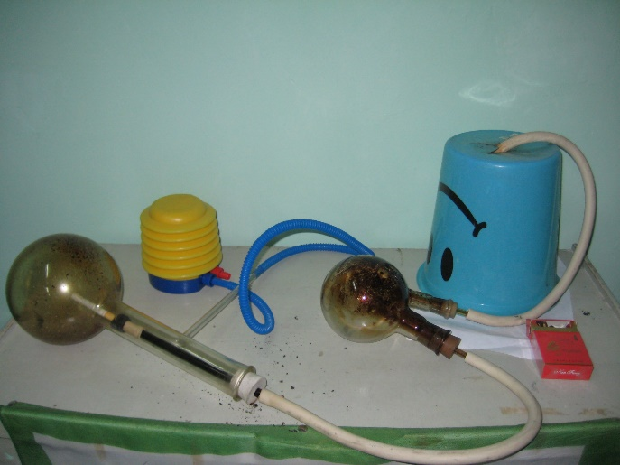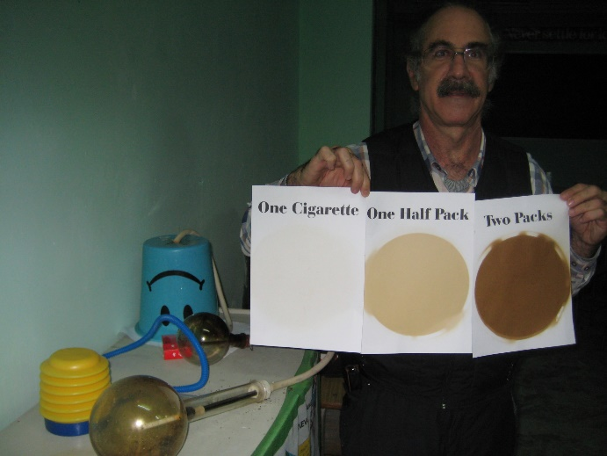
Don invented a “smoking machine” that shows what the smoke that comes out of cigarettes
really looks like. The circle in the middle of the second picture shows what goes into the lungs of a half a pack (10 cigarettes) smoker every day. Every day.
Don发明了一种«吸烟机»，它能显示出香烟喷出的烟雾真实的样子。第二幅图中间的圆圈显示了每天抽半包烟(10支烟)的人进入肺部的物质。请注意：是每天！！！

Don “Orfeo” Rechtman (唐瑞民)
Apt. 16-1701
Blue Bay Community
1588 Aixi Hunan Road, High-tech Zone
Nanchang, Jiangxi, China 330033
南昌市高新区艾溪湖南路1588号，中骏蓝湾小区16栋1701号 邮编330033
电话号码：Phone (China): (+86) 135-2889-6144
微信名：Weixin (WeChat) name: oorfeo
don@orfeomusic.org
个人网页：www.OrfeoMusic.org

Article 48 Women in the People’s Republic of China shall enjoy equal rights with men in all spheres of life: political, economic, cultural, social and familial. The state shall protect the rights and interests of women, implement a system of equal pay for equal work, and train and select female officials. 第四十八条 中华人民共和国妇女在政治、经济、文化、社会和家庭等生活各方面享有与男子平等的权利。 国家保护妇女的权益，实行同工同酬制度，培训选拔女干部。 Article 49 Marriage, families, mothers and children shall be protected by the state. Both husband and wife shall have the obligation to practice family planning. Parents shall have the obligation to raise and educate their minor children; adult children shall have the obligation to support and assist their parents. Infringement of the freedom of marriage is prohibited; mistreatment of senior citizens, women and children is prohibited. 第四十九条 婚姻、家庭、母亲和儿童受国家保护。 夫妻双方都有实行计划生育的义务。 父母有抚养教育未成年子女的义务、成年子女有赡养、扶助父母的义务。 禁止侵犯婚姻自由、禁止虐待老人、妇女和儿童。
- Based on U.S. research published in 2011 in PEDIATRICS 129(1):170-1. As smoking in Chinese homes may be more prevalent than in U.S. homes, this figure based on 28% of the 100,000 non-smoker deaths may actually be higher. https://www.researchgate.net/publication/51925433_Children_and_Secondhand_Smoke_Clear_Evidence_for_Action - 基于2011年发表在《儿科学》129(1):170-1上的研究。吸烟的情况在中国家庭中比美国家庭可能更普遍,根据100000年不吸烟死亡人数的28%这个数字可能会更高。 https://www.researchgate.net/publication/51925433_Children_and_Secondhand_Smoke_Clear_Evidence_for_Action
For a partial list of the Federation’s work regarding smoking, visit their website at http://www.womenofchina.cn/womenofchina/html1/0/82-1.htm?community=womenofchina&lucenelist=8&q=smoking 部分联合会的工作关于吸烟讯息,你可以访问他们的网站http://www.womenofchina.cn/womenofchina/html1/0/82 - 1. htm?community=womenofchina&lucenelist=8&q=smoking

